TITLE OF RESEARCH WORK: WALSAIP - Visual Terrain Explorer

Research Description:

Research and development of a terrain visualization tool (VTE) which aims to provide an integrated visualization system for environmental monitoring applications which combine diverse data acquired through remote sensing techniques.

In order to perform effective interactive terrain visualization, a visualization tool must be capable of drawing accurate and realistic terrain geometry. This requires working with high resolution terrain elevation models and satellite images which are potentially larger than the available memory. In addition, the actual rendering operations required to produce the 3D images from the terrain elevation models are computationally intensive.
As part of this research, we are exploring how design a scalable visualization tool capable of leveraging distributed resources such as remote storage systems, databases, and high-performance distributed computing.

WALSAIP GROUP ASSOCIATION:  Automated Information Processing Group | 
THESIS TITLE:
High-level Description Language for Automated Information Processing in Distributed Systems
THESIS ADVISOR:
Prof. Nayda Santiago
INSTITUTION:
Electrical and Computer Engineering Dept. University of Puerto Rico at Mayaguez
PERSONAL WEBSITE:  http://www.ece.uprm.edu/~veguilla/ | NAME OF RESEACH ASSISTANT:  Ricardo Veguilla González
RESEARCH PROJECT OUTCOMES:
Publications:
R. Veguilla, N. Santiago, D. Rodríguez. Issues in Terrain Visualization for Environmental Monitoring Applications, Fourth Latin American and Caribbean Conference for Engineering and Technology LACCEI 2006, Mayaguez, Puerto Rico, 21 - 23 June 2006

Tools and Applications:

As part of this research, we are using the Java 2 Platform for cross-platform application development and OpenGL for hardware-accelerated rendering. In addition, we will employ Apache Axis, an open source, Java and XML based Web service framework.

The visualization tools will allow easy to use, interactive visual exploration of 3D terrain geometry combined with supplementary information obtain from physical sensors and other existing information sources such as GIS.

RELATION OF RESEARCH WORK TO WALSAIP PROJECT:
The VTE research project will develop an Information Rendering System (IRS) for the WALSAIP project. As an IRS, the goal of this project is to provide a tool for the visual exploration of environmental data obtained through remote sensor arrays and/or produced from computer models. As a client of the WALSAIP system, this project will define a set of distributed operations for terrain geometry simplification and employ the available storage and computation resources in order to performed the required terrain simplification operations, store the resulting data, and make it available to the visualization tool via data streaming.

IMAGE REPRESENTATIVE OF RESEARCH WORK:
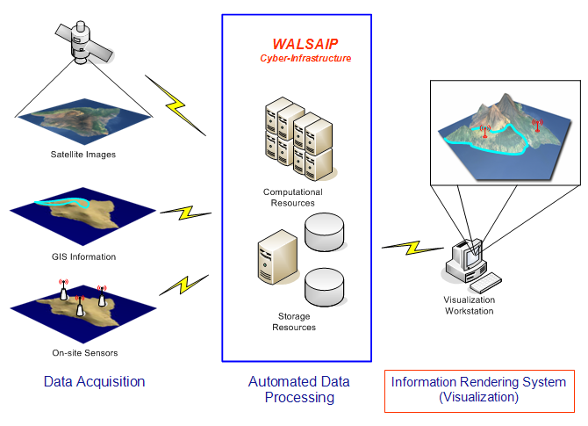

The conceptual model of the WALSAIP-VTE project. The Automated Information Processing capabilities of the WALSAIP project will be employed in order to support the interactive visualization of environmental-related data aggregated from varied sources and displayed over a 3D terrain representation.

RESEARCH DEMONSTRATION:
We have developed a working prototype capable of rendering digital elevation maps of various formats with associated texture images. Various experimental level-of-detail (LOD) rendering capabilities are currently implemented in the prototype. Beyond LOD management, we plan to improve the prototype application by implementing a formal mechanism for out-of-core data management based on Web-Services technologies.

The latest version of the prototype visualization tool, user manual and data files will be available at:
http://ece.uprm.edu/~veguilla/walsaip-vte/demo

