TITLE OF RESEARCH WORK:
A Tool for Mapping Satellite Images to Geographical Areas
Research Description:

The objective of this project is to develop a tool to map images to geographic areas such as cities, shores, lakes, rivers, basins, wetlands, forests, and any other classification necessary and store them for current or future work. The mapping tool will be instrumental in creating image databases that will facilitate the search of the images. For example, a user could provide a map of all the cities of Puerto Rico with labels identifying them and a database of satellite images of Puerto Rico and the tool will generate database entries with references to the images corresponding to each city. Similar mappings could be made of other regions creating databases that can facilitate searching for images of geographical areas. Thus, a user no longer will need to remember the coordinates of a region to find images of that region. She/he only needs to enter geographical keywords and a search engine will come up with references to the images corresponding to the region of interest. The mapping tool will be available to users through the Web so that they can add their mappings of interest to the database of the website. Thus, their mappings will become searchable mappings for other users.

WALSAIP GROUP ASSOCIATION:  Human Computer Interfaces Group | 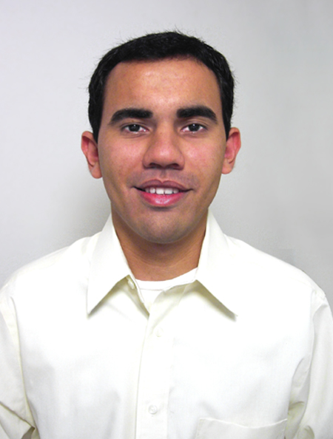
THESIS TITLE:
Tool for Mapping Satellite Images to Geographical Areas
THESIS ADVISOR:
Prof. Néstor J. Rodríguez
INSTITUTION:
Electrical and Computer Engineering Dept. University of Puerto Rico at Mayagüez
PERSONAL WEBSITE:  http://www.ece.uprm.edu/~s978731/ | NAME OF RESEACH ASSISTANT:  Omar Valenzuela-Agosto
RESEARCH PROJECT OUTCOMES:
Publications:
At this moment there are no publications related to this project.

Tools and Applications:

1. Apache HTTP Server
2. PostgreSQL
3. PHP
4. JavaScript

These four programs or applications together provide a place to store a dynamic website capable of creating powerful applications using PHP script programming and JavaScript. Apache provides the HTTP Server capable of serving websites where strong scripts like PHP can compile its code and embed content into HTML code.

JavaScript is what makes PHP become dynamic, only if the AJAX technique is used. JavaScript can change the HTML inside a website without having to reload the entire code of the website. This alone allows the website to exchange information faster with the server. Exchanging data faster with the server means that queries to the DBMS will benefit from this technique.

5. Adobe’s Dreamweaver (previously called Macromedia’s Dreamweaver)
6. Interakt PHAkt extension for Dreamweaver

Dreamweaver is an editor for HTML, PHP, and MySQL DBMS. PHAkt extension for Dreamweaver allows the software to use PostgreSQL and other popular DBMS applications.

RELATION OF RESEARCH WORK TO WALSAIP PROJECT:
Within WALSAIP’s Conceptual Framework the mapping tool will be a target application at the User Interface Information Substrate. The tool will be available to the hydro-ecological researchers of the project.

IMAGE REPRESENTATIVE OF RESEARCH WORK:
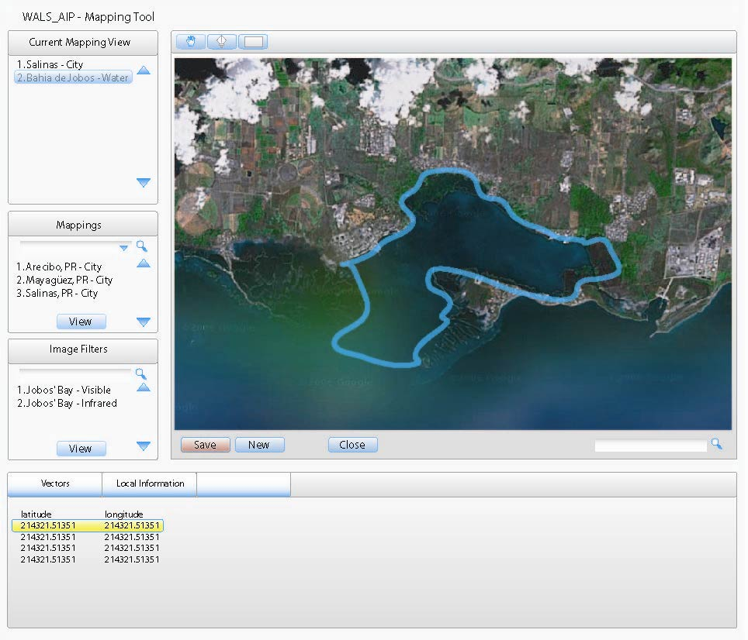
This image shows the proposed User Interface for the mapping tool. “Current Mapping View” box will show the current images being used in the work screen. “Mappings” box will show the mappings available for the current image. A preview of one mapping is the blue line that marks the bay in the image above; Jobo’s bay. The bottom box will display relevant detailed information that corresponds to the current image and/or mappings. At last, the map area contains tools that enable the researcher to create new mappings and save them to the DBMS.
RESEARCH DEMONSTRATION:
The proposed mapping tool is a web-based application that will be made available for use by the general public. A prototype of the tool will be available by mid fall. This prototype will served as a demonstration application and will be made available to the public by disseminating its web address. Subsequent versions of the tool will be available to the publics as the tool is being enhanced.

