TITLE OF RESEARCH WORK: An Energy-Efficient MAC Protocol for Wide Area Large Scale Environmental Monitoring
Research Description:

The research consisted in implementing the protocol we previously developed into mica2 and mica2dot nodes. Our protocol had been tested before in Network Simulator 2 (ns-2) and proved to be more energy efficient than other existing protocols.

During the summer, some features of our protocol were implemented into mica2 and mica2dot nodes with MTS403 sensor boards. Currently, the new schedule proposed for our protocol has successfully been implemented into the nodes in order to save energy by avoiding idle listening.

WALSAIP GROUP ASSOCIATION:  Network Communications Infrastructure  Group | 
THESIS TITLE:
An Energy-Efficient MAC Protocol for Wide Area Large Scale Environmental Monitoring
THESIS ADVISOR:
Prof. Yi Qian
INSTITUTION:
Electrical and Computer Engineering Dept. University of Puerto Rico at Mayaguez
PERSONAL WEBSITE:  http://www.ece.uprm.edu/~miguel/ | NAME OF RESEARCH ASSISTANT:  Miguel Angel Erazo Villegas
RESEARCH PROJECT OUTCOMES:
Publications:

[1] An Energy-Efficient MAC Protocol for Wireless Sensor Networks for Wide Area Large Scale Environmental Monitoring”, Fourth LACCEI International Latin American and Caribbean Conference for Engineering and Technology LACCEI’2006, Mayagüez, Puerto Rico, 2006.

Tools and Applications:

In order to implement the protocol we used: TinyOS running on windows with Cygwin, 2 mica2 nodes with MTS403 sensor boards, 4 mica2dot nodes and Crimson editor.

The first task was to implement the schedule of our protocol. In order to do that we used S-MAC’s underlying synchronization where nodes periodically sleep and wake up. Our protocol is based on the idea that nodes only wake up when a sample will be taken from the environment or when an interesting event happens. Thus, we had to find a way to synchronize nodes in such a way that they all get synchronized with the Base Station and we wanted this procedure to be programmable and automatic. We used data packets that nodes send periodically which carry temperature, humidity, barometric pressure and light samples to synchronize nodes. A node, upon receiving the first data packet, receives information about TCALP and NLSP [1] from the Base Station and they use that information to run the proposed schedule running on top of the underlying one. The Base Station periodically sends synchronization data to resynchronize nodes in case they lose synchronization sometime.

The second task was to get the appropriate driver and component in NesC to sense temperature, light, pressure and humidity. We found good components which allow to sense all variables we want which are: SensirionHumidity.nc, Hamamatsu.nc and IntSensirionHumidity. The advantage of these components over the one we are using (PhotoTemp) is that the data they send is automatically converted to engineering units through the XListen application provided by Crossbow. Also, it was observed that their samples are more accurate than those provided by PhotoTemp. Therefore we wanted to replace the PhotoTemp.nc component with these new ones. However, these components run under the Berkeley stack and the code we used as base pertains to other stack and we have been having some problems of compatibility. I am currently working on moving our protocol to the Berkeley stack so we can use all components available.

For the time being, nodes send information about temperature, pressure, light and humidity directly to the Base Station in a one hop configuration using the PhotoTemp.nc component. Currently, our protocol’s multi-hop capabilities are being developed so the nodes can act also as routers instead of just sending packets to the Base Station. It is not our objective to configure a whole routing protocol that runs on top of our protocol, instead, we want to configure static routing on our nodes.

RELATION OF RESEARCH WORK TO WALSAIP PROJECT:
WALSAIP is interested in storing, processing and analyzing data sampled from the environment. For that purpose it is extremely important that nodes consume the least amount possible of energy with near zero packets lost. In order to meet those objectives it is my duty to design, simulate and implement a suitable MAC protocol that consumes the least amount possible of energy and at the same time be reliable. My duties include: collection of samples from the environment (temperature, light, pressure and humidity), reliable transport of packets to the Base Station and conversion of data sampled to engineering units for further processing.
IMAGE REPRESENTATIVE OF RESEARCH WORK:
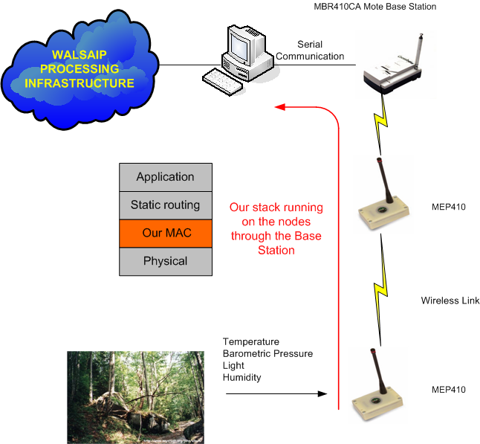

The picture shown above shows the area I am responsible for. The complete process is the following: 1) samples from the environment are taken at regular intervals 2) The nodes that sense this data generate corresponding packets 3) Packets generated are conveyed from node to node to the Base Station with our Protocol 4) The Base Station sends packets it received by using Serial Framer Protocol 5) A workstation converts data to engineering units and passes it to the next stage in the WALSAIP project.

RESEARCH DEMONSTRATION:
Currently, I do not have a research formulation because more work is needed in order to completely implement the protocol. In the near future I will be able to show a prototype in which I will show how our protocol, sensing the same parameters as others consumes less energy at the same throughput.

My prototype will consist of showing results of packets transmitted/received vs. energy consumed. Furthermore I will build a small sequence of pictures showing how nodes organize themselves and transmit packets with our protocol.

