TITLE OF RESEARCH WORK:
Automated Composition of Signal Processing Operators.

Research Description:

The goal of this project is to develop a grid-based tool to define workflow composition of signal processing operators as an application service. This tool will allow the composition of operators that may be geographically distributed and provided by diverse administrative domains. Underlying this tool there will be existing grid technologies such as Globus Toolkit 4.0 and Gridsphere. The design of the methodology for composing distributed signal operators follows two major requirements. Firstly, it is desirable to optimize resource management according to the complexity of the operators to be processed. Secondly, the composition of distributed resources requires metadata distribution and management mechanisms.

WALSAIP GROUP ASSOCIATION:  Parallel and Distributed Computing Group | 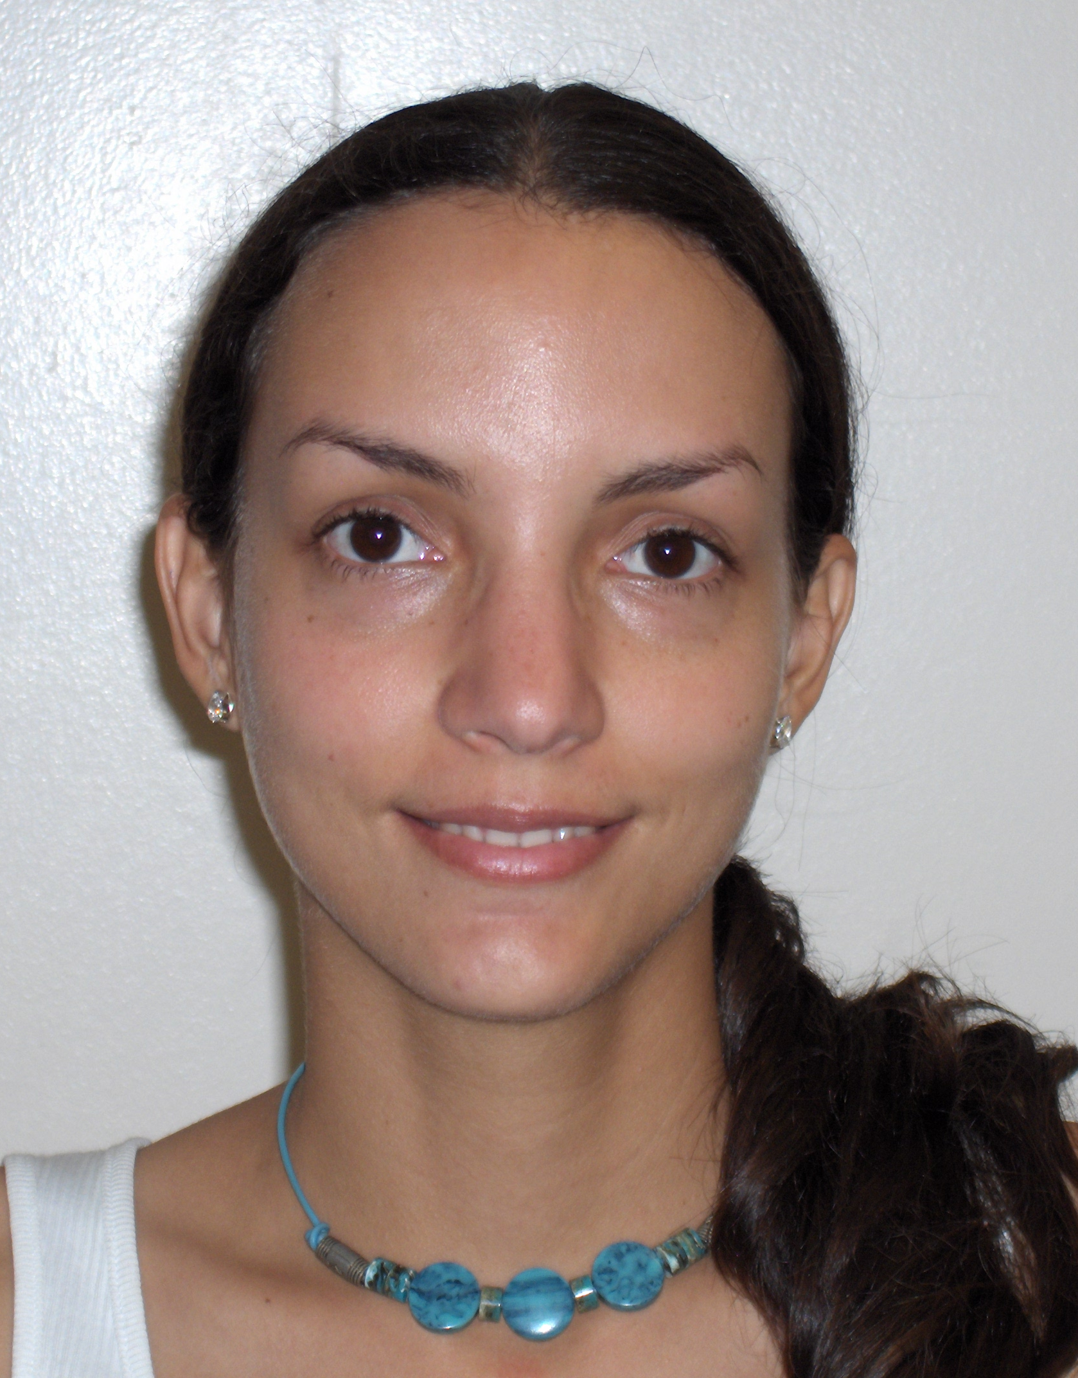
THESIS TITLE:
Automated Composition of Signal Processing Operators.
THESIS ADVISOR:
Prof. Wilson Rivera
INSTITUTION:
Electrical and Computer Engineering Dept. University of Puerto Rico at Mayaguez
PERSONAL WEBSITE: | NAME OF RESEACH ASSISTANT:  Mariana Mendoza
RESEARCH PROJECT OUTCOMES:
Publications:

Tools and Applications:

Globus Toolkit: (http://www.globus.org)
The Globus Toolkit (GT4) is an open source middleware used for building grid systems and applications. The GT4 includes a basic installation of Java WS Core and base grid services such as a security infrastructure (GSI), data transport service (GridFTP), execution services (GRAM), and Information services (MDS). We use GT4 as the technology underlying the tool for composition of signal processing operators.

GridSphere Portal Framework: (http://www.gridsphere.org)
The Gridsphere Portal Framework will be used to build reusable portal components that can be integrated in a common portal container system. Gridsphere is based on the notion of a “portlet,” a portal server component that controls a user-configurable pane in the user’s web browser. A portal server supports a set of web browser frames, each containing one or more portlets that provide a user service. This portlet component model allows one to construct portals merely by instantiating a portal server with a domain specific set of portlets, complemented by domain-independent portlets for collaboration and discussion. Using the Gridsphere, one wraps each grid service with a portlet interface, creating a “mix and match” palette of portlets for portal creation and customization. The resultant grid portal will hide the administrative complexity of the application via easy-to-use interfaces.

Java Language: (http://java.sun.com/)
We will use Java like object-oriented programming language to implement the signal processing grid services.

Java Advanced Imaging (JAI) API: (http://java.sun.com/products/java-media/jai/)
The Java Advanced Imaging API provides a set of object-oriented interfaces that support a simple, high-level programming model to manipulate images easily. We will use this API to execute signal processing operators on images.

RELATION OF RESEARCH WORK TO WALSAIP PROJECT:
The WALS-AIP project aims at developing an infrastructure for the treatment of signal-based information arriving from physical sensors in a wide-area, large scale environment. This particular research work contributes to this goal by developing a tool to automate composition of signal processing operators in a distributed environment.
IMAGE REPRESENTATIVE OF RESEARCH WORK:
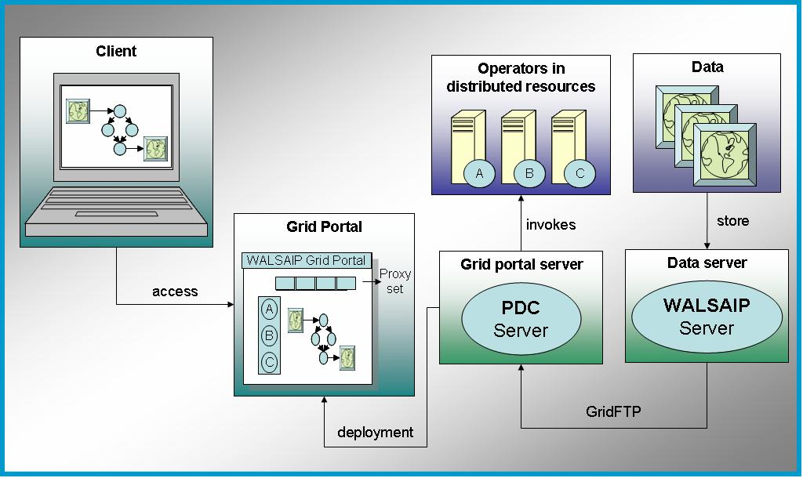

The Grid Portal Interface provides transparent and secure access to end-users. This interface allows end users to define signal processing workflows by using drag and drop functionalities. GridFTP is used to improve data transport from the data server (WALSAIP Server) to the Grid Portal server (PDC Server). Signal processing operators are deployed as grid services. This grid services may be geographically distributed and provided by different administrative domains.

RESEARCH DEMONSTRATION:
The first Grid portal prototype is available at http://pdcgrid-32-01.ece.uprm.edu:8080/gridsphere/
(Login and password: guest). Portlets are in WALSAIP Portlets tab. Each portlet shows an operator description and a list of images stored in Walsaip server (Figure 1). Users can apply signal processing operators to the images (Figure 2).

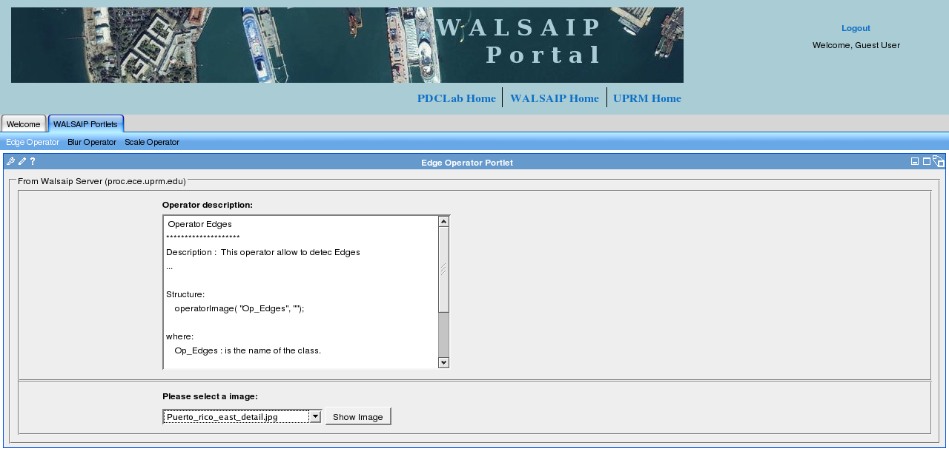
Figure 1. Edge operator description and list box to choice the image.

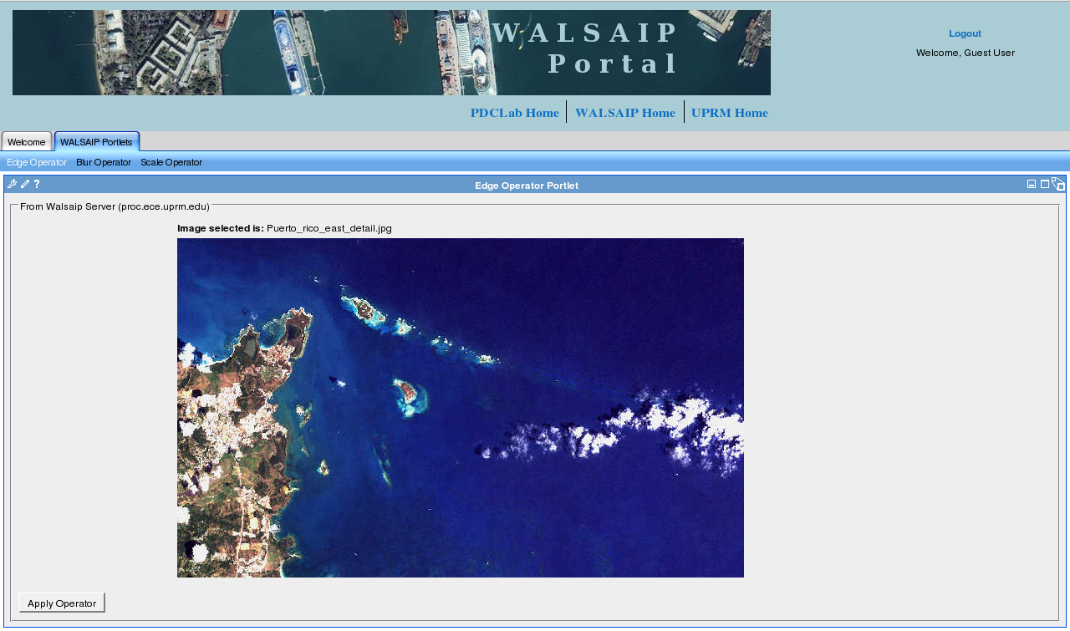
Figure 2. The image selected to operate.

