TITLE OF RESEARCH WORK: Automated XML Schema Representation in Sensor Array Processing System
Research Description:

This research aims to provide solution to two very common situations on remote sensing data collection and exchange: the lack of direct relationship between data and metadata files and the ambiguity of interpretation between different users with different systems (software in which data / metadata will manipulated/processed), and platforms (linux, Windows, Unix,..etc).
Sensed data is data that comes directly from sensors. In addition to the environmental readings from sensors, additional information is crucial for decision making such as sensor identification, reading timestamp, physical location of sensor among others. Metadata is a determinant of how the environment influenced the measurement in case of abnormal findings. Generally, data is taken directly by sensors and some of the metadata as well, but saved in different files. In cases, there is a need to alter the metadata file to add more specific information not provided by sensor such as institution or agency conducting the research, principal investigator, contact information, etc. This additional information is helpful for research discovery, back tracking reference in case of data exchange between different users/researches, suggestions input, collaborative efforts and so on.
In addition, different sensors have particular data representation standards that can represent a hazard for data availability to external users. Understanding the meaning of the content of data and metadata files can be a time consuming task not to mention the dependency of systems and platforms. To deal with the ambiguity of interpretation this work explores XML as a solution. XML (eXtensible Markup Language) is a general purpose markup language capable of describing many different sets of data. XML provides a text-based means to describe and apply a tree-based structure to information. An XML data set can be self sufficient providing the data, the description of the data and the relationships between the data. This flexibility has positioned XML as one of the top choices for data sharing between different systems that might have nothing in common except their XML capabilities.
In conclusion, this research focuses on the design and implementation of a Java-based application to automate the encapsulation of data and metadata files into a single XML file. This new file, due to well known xml standards and protocols, will be suitable for network transmissions and to be share in heterogeneous environments with similar xml capabilities.

WALSAIP GROUP ASSOCIATION:  Automated Information Processing Group | 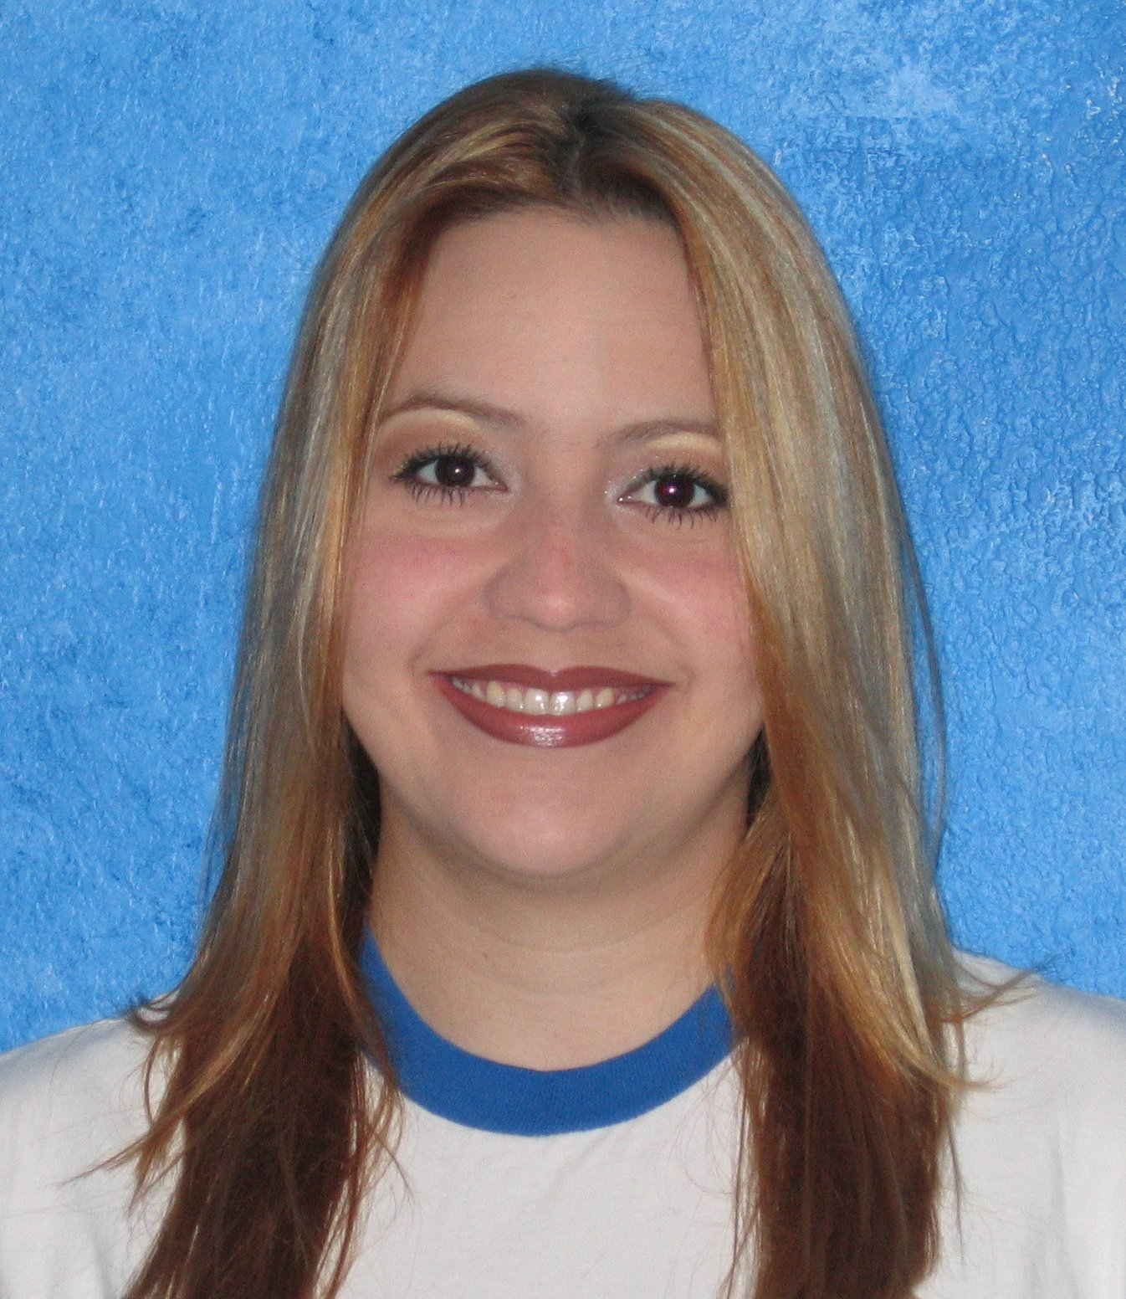
THESIS TITLE:
Automated XML Schema Representation in Sensor Array Processing System
THESIS ADVISOR:
Prof. Domingo Rodriguez
INSTITUTION:
Electrical and Computer Engineering Dept. University of Puerto Rico at Mayaguez
PERSONAL WEBSITE:  https://ece.uprm.edu/~s980021/luz_acaba_cuevas/ | NAME OF RESEACH ASSISTANT:  Luz Veronica Acaba-Cuevas
RESEARCH PROJECT OUTCOMES:
Publications:

Tools and Applications:

As part of the design and implementation, several tools are being used.

Previous Work
- Searching over the Internet to find similar works and find vulnerabilities to be covered with this solution.

Technologies
  - Java – the entire solution will be coded in Java. Java is widely accepted by open source community. In addition, Java is portable (meaning it does not depend on any arquitecture or operating system). Java is object oriented. Also, easily integrated by the use of well documented APIs with well known technologies.
  - FTP (File Transfer Protocol) - FTP allows files of any type to be transferred between a server and a client across a TCP/IP network. If any client or information source wants to receive data transmitted, it will be necessary to have FTP services running in combination with a FTP server.
- XML (eXtensible Markup Language) – is a general purpose markup language capable of describing many different sets of data. XML provides a text-based means to describe and apply a tree-based structure to information. XML will be used to add the description labels to every piece of information in the merged data/metadata file. This will ensure ambiguity of interpretation and data availability to heterogeneous users.

Software
- IBM Rational Software Architect version 6.0 – IBM Rational Software Architect is an integrated design and development tool that leverages model-driven development with the UML for creating well-architected applications and services.

RELATION OF RESEARCH WORK TO WALSAIP PROJECT:
WALSAIP Project is developing a new conceptual framework for the automated processing of information arriving from sensors in a generalized wide-area, large-scale distributed network infrastructure. This research will provide common files definition and communication protocols for data exchange within the WALSAIP users community Every WALSAIP server will be capable to encapsulate data and metadata for to transmission.
IMAGE REPRESENTATIVE OF RESEARCH WORK:

The diagram above shows the three aspects that represent a hazard to data availability and interoperability: heterogeneous system platforms, data architectures, and data processing systems. There will be no way to know in advance what configuration resides on the user end. There is a need to create a mechanism able to deal with the interoperability that result transparent to the user. Data should flow from information source to information destination without difficulties. The user will be able to encapsulate/extract data and metadata files into a single XML files without previous knowledge of XML. The same way, the user will not require knowledge of FTP to transport data over TCP/IP connection.
RESEARCH DEMONSTRATION:
Solution Proposal

Solution:

Design and implementation of Java-based application to automate the encapsulation of data and metadata files in a single XML file suitable for transmission purposes avoiding ambiguity of interpretation. This application will be installed on every server part of the WALSAIP cyber-infrastructure and will be the standard application for data / metadata encapsulation and transport to other WALSAIP servers.

Listing of Functional Requirements:

- Encapsulation: This action will take as an input two files, data and metadata and generate an XML file as the output. This function will allow the user to specify the names or labels of each piece of information to be transferred. FTP (File Transfer Protocol) technology will be used as the protocol to transfer files. Encapsulation can be performed even if the user doesn’t desire to transfer data. The user will have the option of encapsulate data/metadata and save it locally on the workstation for later transmission with this tool or with other mechanism such as email.

- Extraction: Take as the input one XML file and split it in two files: data and metadata. There is no warranty that the systems installed on any particular server will support XML for data processing purposes. For that reason, the tool provide the feature of separating data and metadata into two separated files in order to have data in the most common way used without forcing any particular data format to the user.

- Transport: This feature will provide a list of the servers that are available for data destination. Then the XML file that will be transmitted is selected trough a browse feature. Only XML files can be transmitted.

- GUI: The user will have access to all functions trough a graphical user interface (GUI). This will enable the user to interact with the functions through direct manipulation of graphical images and widgets in addition to text. Usability guidelines will be used for the design and implementation of the GUI in order to reduce training time and maximize ease of use.

- Editing Clients: This function will enable the user to add, remove and edit the list of servers to transmit XML data/metadata files. The list of participant servers will be fully customized by user.
Quality requirements or other requirements:
- Usability – The use of usability guidelines for this solution seek to shortening the time to accomplish task by reducing the number of mistakes made and reducing learning. This will lead to get peoples satisfaction with the system.
- Reliability – the main three activities to ensure software reliability that will be applied to the design and implementation are:
  - Error Prevention – the application will provide mechanism to avoid users to commit errors. For example, instead of entering text, the user can choose values from lists (where applicable).
  - Fault detection and removal – the solution will provide error correction/detection code to validate entries from users.
- Supportability – XML and Java will provide the platform to make this solution available to heterogeneous users with different data architectures, systems, and platforms.

