TITLE OF RESEARCH WORK: A Signal Algebra Operator Approach to the Analysis and Design of Image Processing Algorithms for Java-based Web-enabled Applications
Research Description:

This work deals with the implementation of a Java-based environment (called J-CID) which provides a set of operators for Image Processing according to the constraints imposed by the Signal Algebra of complex-valued images. Implemented operators includes Point operators (Absolute value, Clamp, and Color Convert), Arithmetic operators (Addition, Subtraction, Multiplication and Division between images and by constants; also includes Exponential and Log operations), Spatial operators (Invert color, Crop, Resizing, Rotation, and Flipping), Morphological operators (Dilation and Erosion), Convolution operators (Sharpening, Blurring, Embossing, Edge Detection which includes Sobel, Prewitt, Freichen and Roberts; Filtering which includes Low Pass, High Pass, Laplacian and Gaussian; and 2D Fast Fourier Transform), Cyclic operators (Cyclic Convolution and Cyclic Correlation) and Complex operators (Conjugate, Phase, Hadamard Product and Shifting).

This environment has the option of allowing end-users to add their own customized algorithms as encapsulated operators. Other features of the environment are the remote connection via Java FTP in order to get image files from remote machines, and the connection to a central database that contains raw data acquired by some sensors configured for the research.

WALSAIP GROUP ASSOCIATION:  Automated Information Processing Group | 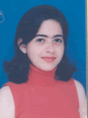
THESIS TITLE:
Web-based Data Processing for Hydro-ecological Applications
THESIS ADVISOR:
Prof. Domingo Rodriguez
INSTITUTION:
Electrical and Computer Engineering Dept. University of Puerto Rico at Mayaguez
PERSONAL WEBSITE:  http://www.ece.uprm.edu/~s040639/ | NAME OF RESEACH ASSISTANT:  Lola Xiomara Bautista Rozo
RESEARCH PROJECT OUTCOMES:
Publications:
J. Villamizar, L. Bautista, D. Rodríguez. A computational signal processing system for correlated digital Interferometry, Proceedings of the 25th Midwest Symposium on Circuits and Systems. August 2005.
Tools and Applications:

The core of the application has been implemented using Java 2 Platform, Standard Edition, v 1.4.2. Some of the operators invoke methods from the Java Advanced Imaging (JAI) API which supports a simple programming model to manipulate images. Also it is used the Java Image I/O API which provides “a pluggable architecture for working with images stored in files and accessed across the network”. As development environment it is being used Eclipse 3.2, because its attributes of being open source and multiplatform.

In order to take advantage of some of the main functionalities of the Image Processing Toolbox of MATLAB, it is being used an interface between Java and MATLAB 7.0. This interface is a JAR (Java ARchives) file which establishes the communication between de Java Virtual Machine (JVM) of Java and the JVM of MATLAB.

Java FTP software from jMethods is used to establish the remote connection to different machines. This software is open source and allow us the availability of integrate it to the main file application of JCID.

As database manager it is being used PostgreSQL 8.0 because it can connect directly to the own database that belongs to the software manager of the data acquisition from the sensors (MoteView).

RELATION OF RESEARCH WORK TO WALSAIP PROJECT:
Related to WALSAIP project, this work contributes to provide a software tool for image analysis which could facilitate the work of scientists of related areas to environmental sciences, in this moment in a local manner, and soon in a distributed manner.

IMAGE REPRESENTATIVE OF RESEARCH WORK:
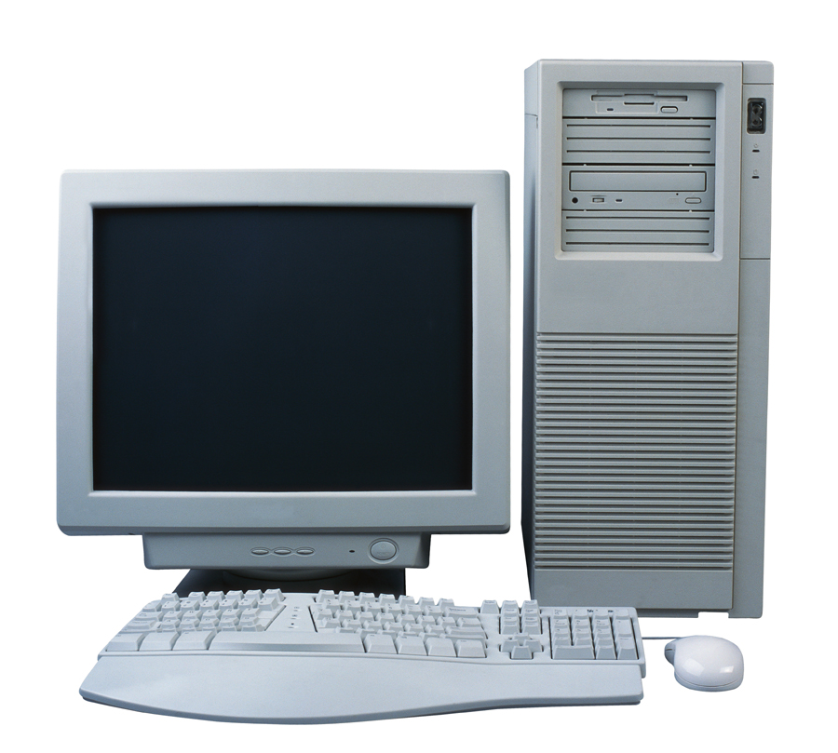
Static Information
Technology
Services
RDS-1
RDS-2
RDS-N
User’s
workstation
Java Image Processing
Matlab Image Processing
Offered Web Services
Geographical Information System
Java FTP
User’s request

This scheme shows a local user configuration. This considers that user can operate over the information he/she has in its own system, and from remote machines using Java FTP as channel of communication. User can make use of utilities from J-CID (the Java environment), MATLAB and the GIS he / she has installed.

RESEARCH DEMONSTRATION:
A prototype has been defined as “an implementation entity with an associated user’s guide”. A research demonstration is a manner of best showing to the public a basic prototype of your research work where you have succeeded in implementing novel software/hardware entities such as concepts, tools, and application services.

Please provide in this section a description of your research demonstration and how to have access to such demonstration if you have succeeded in developing a demonstration. If you DO NOT have a research demonstration at this time, please used this space to formulate a proposal for a research demonstration. Please, be advised that your proposed research demonstration MUST be completed by Friday, December 1, 2006, when you MUST submit a progress report of your on going research work. This progress report will be utilized as one of the decision elements for the availability of WALSAIP research assistantship funds for the second semester of the 2006/2007 academic year.

